**PRACTICAL NO:-4**

**a. Create a Registration form to demonstrate use of various Validation controls.**

1. **RequiredFieldValidator:-**



Set the attribute value of controltovalidate to the textbox to applied it and ErrorMessage that want to display.

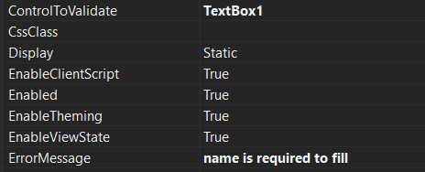

**2)** **RegularExpressionValidator**



Set the attribute value of controltovalidate to the textbox to applied it and ErrorMessage that want to display

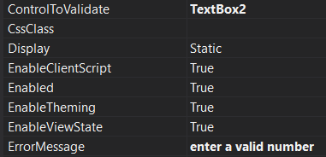

**Also here set the value of regular expression**



**3)** **CompareValidator1**

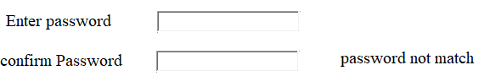

Here we first decide the textbox to controltoCompare and second to which we will compare to compare controltovalidate to second textbox and also the set errormessage.

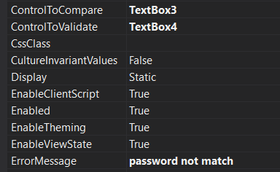

**4)** **RangeValidator**



here we set the textbox and ErrorMessage and also the minimum value maximum value for that textbox

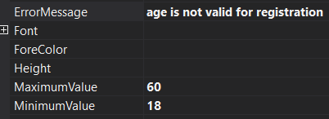

**5)CustomValidator**



Here we first defined the textbox the error warning message

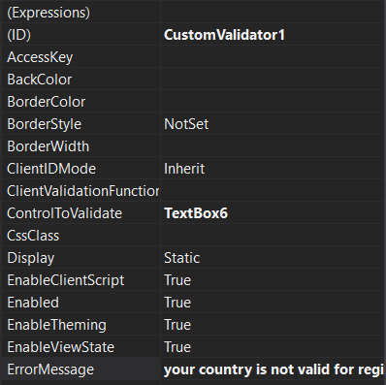

And also Importantly we defined the function for its execution i.e. custom validate function.

You can double click it to open the validator to open function.

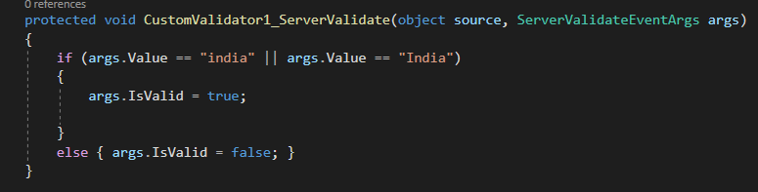

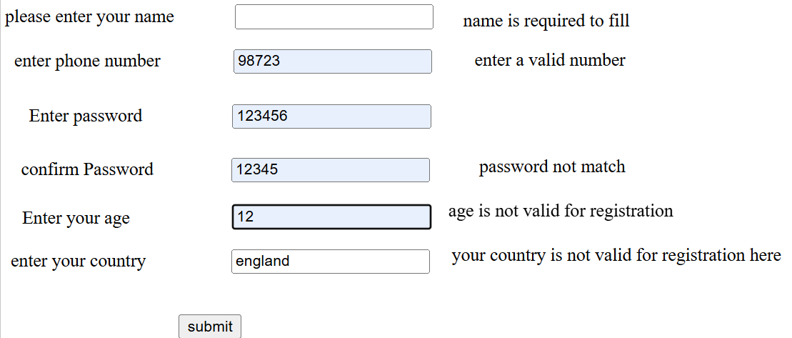

**Correct data:-**

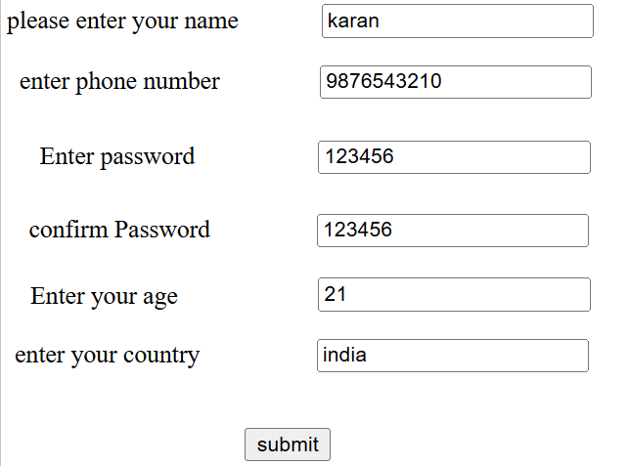

**b. Create Web Form to demonstrate use of Adrotator Control.**

Here first we create a new item that is xml file .In which we create a xml format for adrotator.

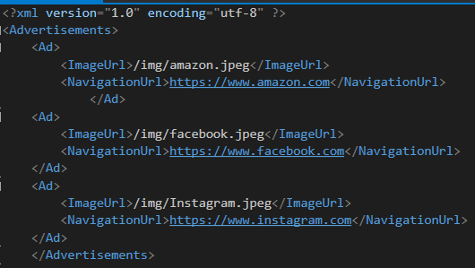

Now in Adrotator we add new data source and we add data and configure it to the above created xml file as below:-

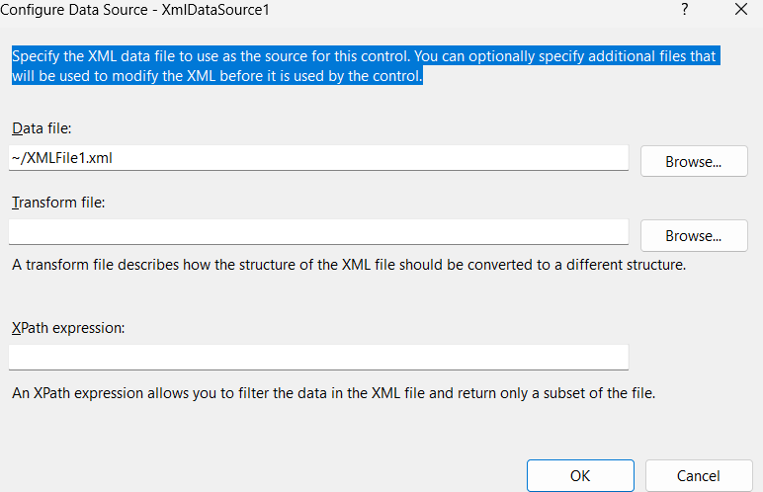

**OUTPUT:-**





**c. Create Web Form to demonstrate use User Controls**

Here we first create user control web form in which we add the content that we want to display on another pages.

Here I wrote some code related to user control panel.

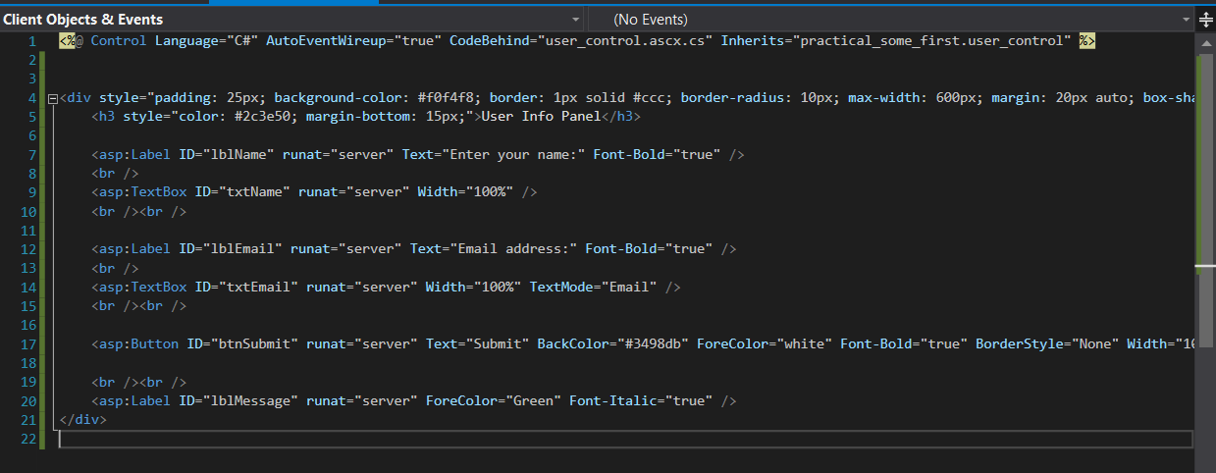

This file is with .ascx extension. We can’t execute this file.

Now we open the aspx file and drag and drop this file from solution explorer. And now we are able to see this in output.

**OUTPUT:-**

